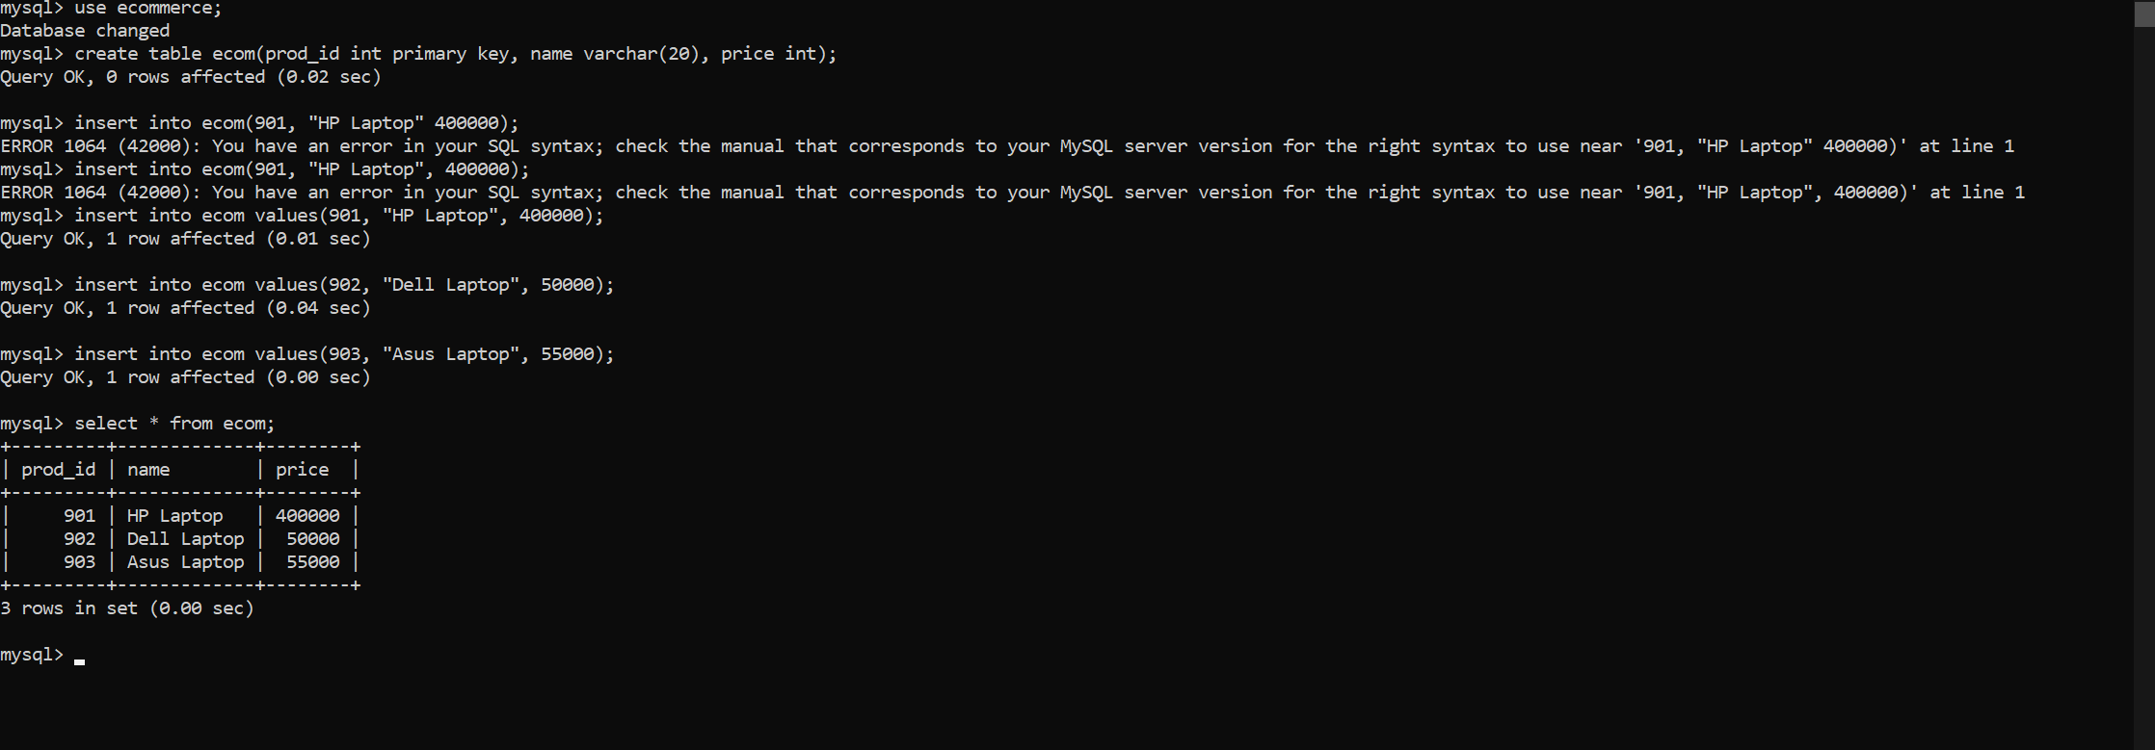

The above is the database created and table is created and values are inserted.

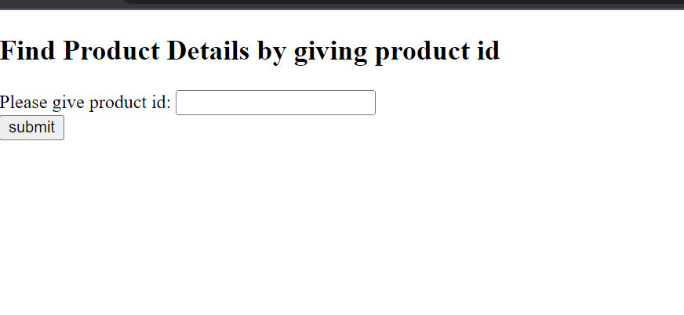

User are allowed to enter the product, they will get the price of that product

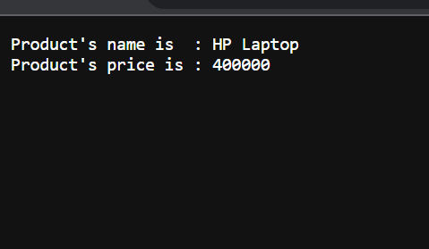

This is the output user will get.